GTPS Facebook Page
Our students volunteering at Spring Gardens
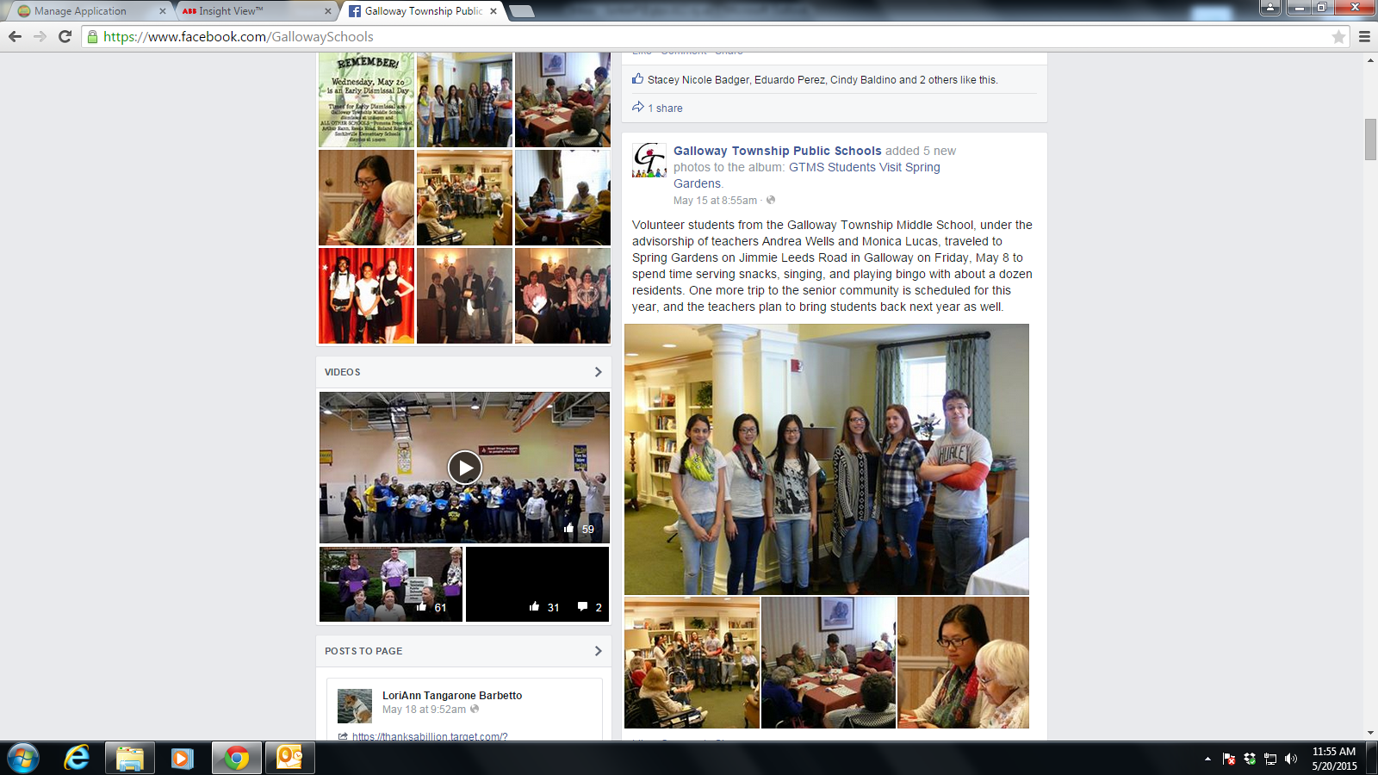
Pasta Drive GMTV Commercial:
VISIT
https://www.youtube.com/watch?v=hKXBiz04lHk
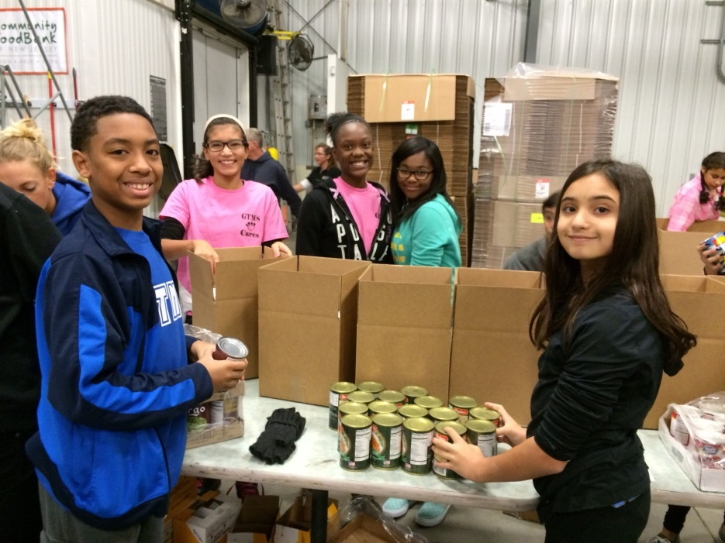 Volunteering at the Food Bank

