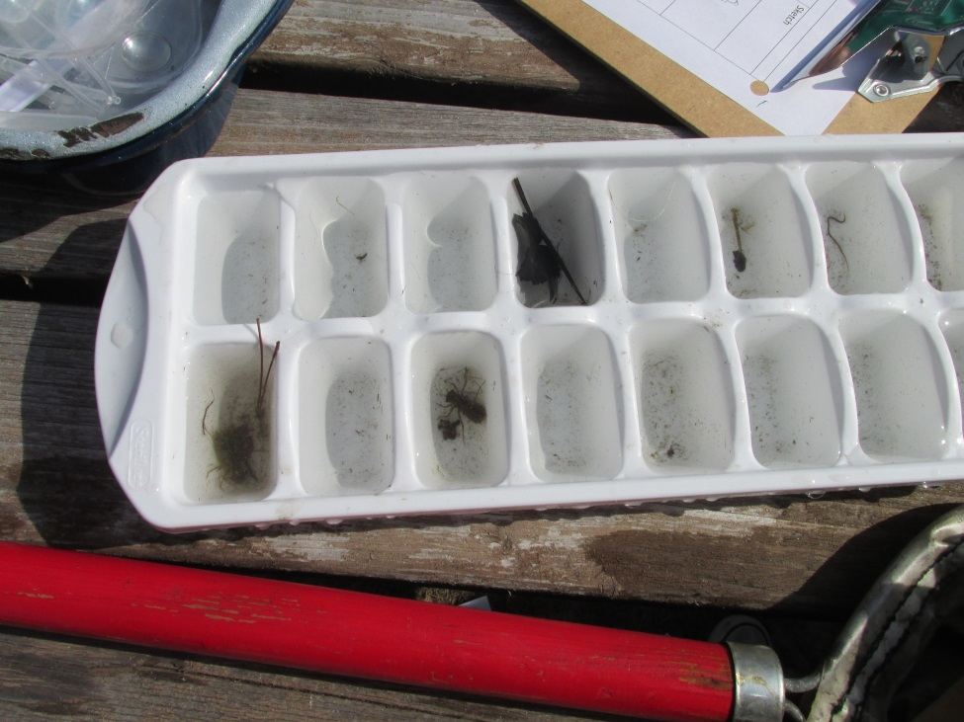
Photos from the Watershed/Microinvertebrate Lesson in our Mr. B’s Backyard Classroom

