***OPEN HOUSE 2014***

**Selling Plants from the Garden**

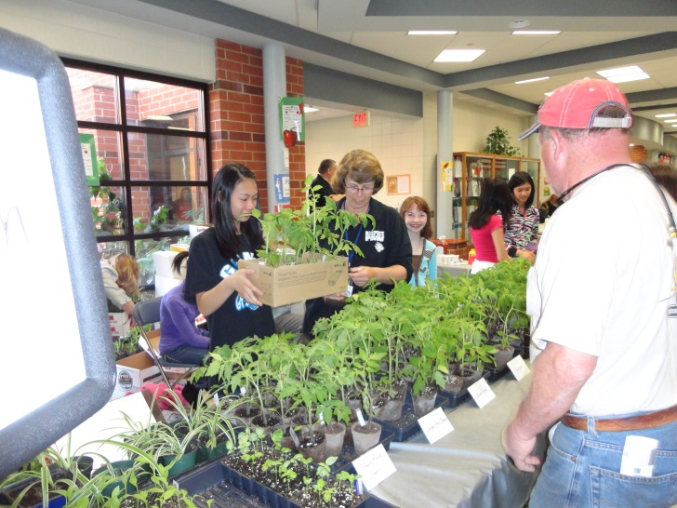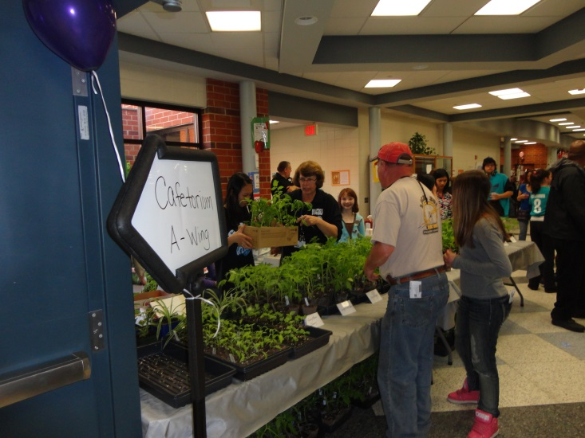

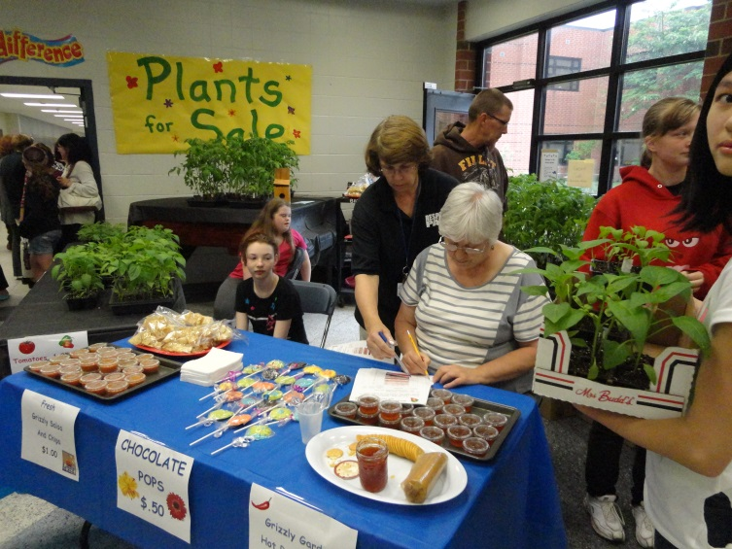

Grizzly garden Hot Sauce (made from the ingredients from garden) and Plant Sale

**Environmental Club – Selling Recyclable Jewelry**

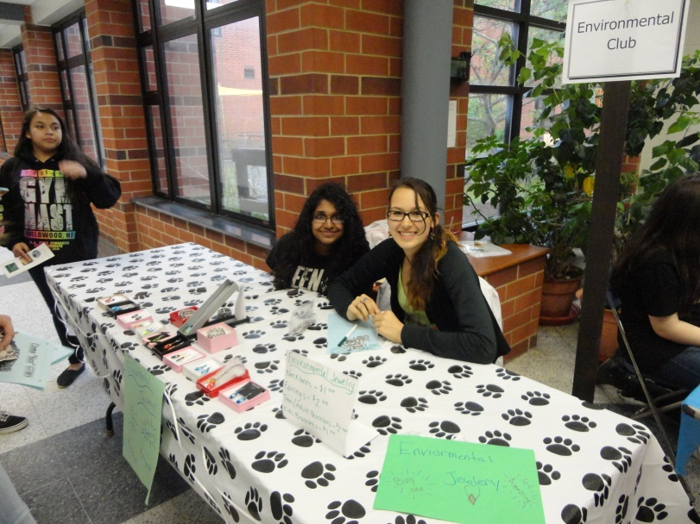

**Healthy Snacking**

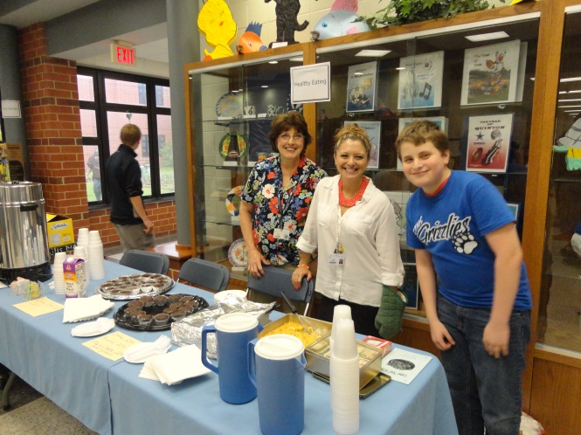

***OPEN HOUSE 2015***

**Healthy Snacking**

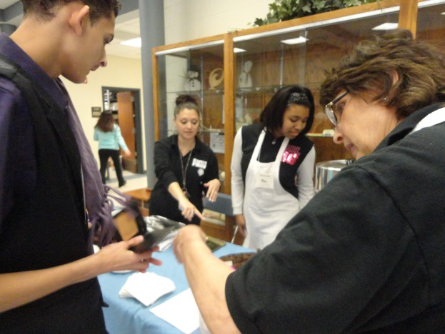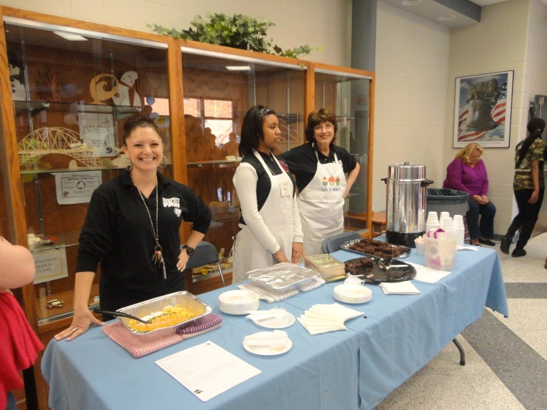

**Fitness Room** 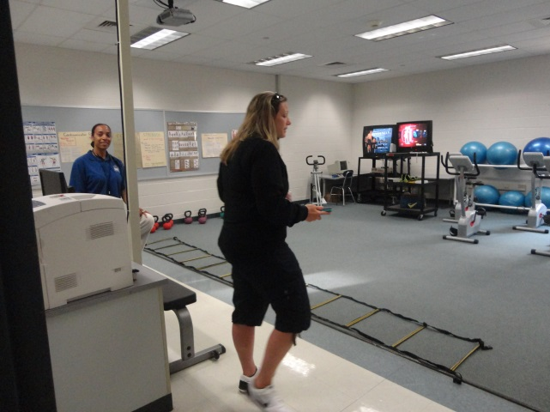 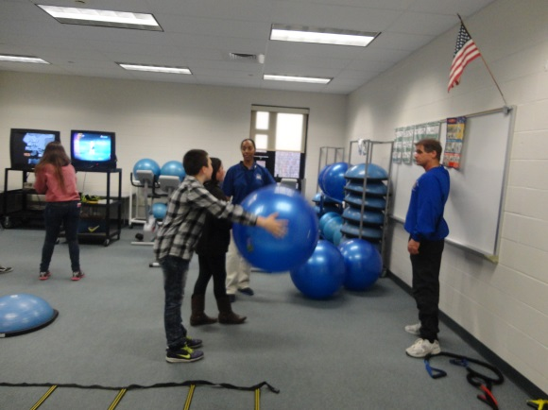

**Tea and Jazz in the Grizzly Garden**

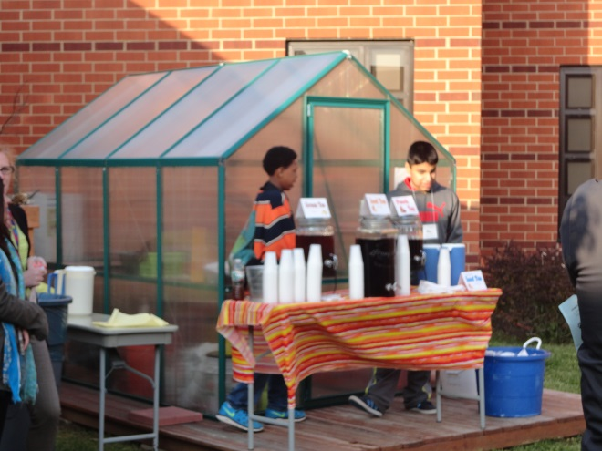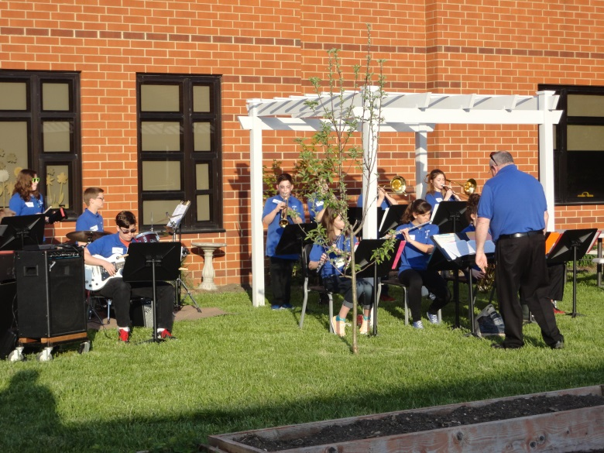

**Environmental Club and reusable T-shirts Partnered with Absegami Earth Shipyards.**

