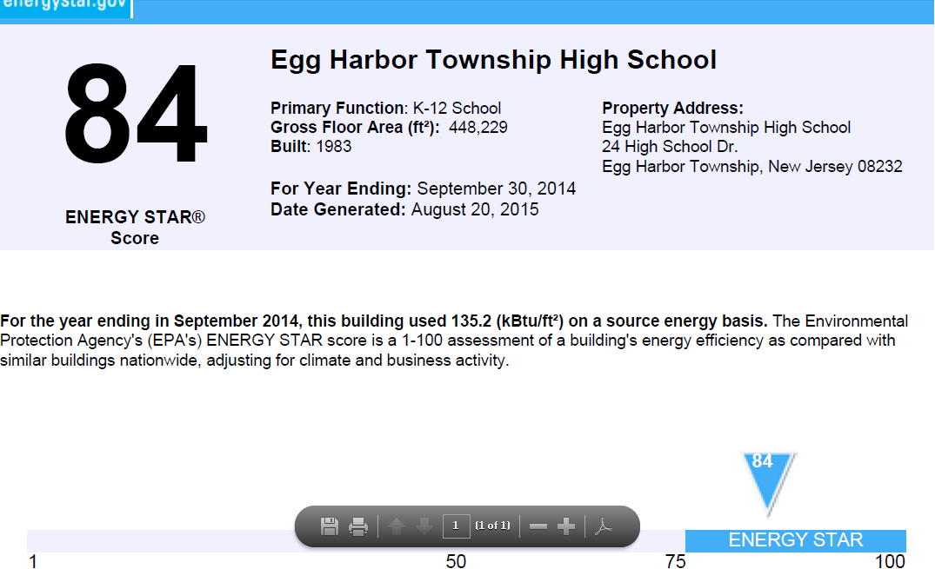

Alder Avenue Middle School  [ Map It! | Profile ]  25 Alder Avenue  Egg Harbor Township, NJ 08234 | Facility Type: K-12 School  Owner: Egg Harbor Township School District  Property Maager:  Label Years: 2013, 2014
Arthur M. Judd Elementary School  [ Map It! | Profile ]  1601 Roosevelt Avenue  North Brunswick, NJ 08902 | Facility Type: K-12 School  Owner: North Brunswick Township Board of Education  Property Manager: North Brunswick Township Board of Education  Label Years: 2012
Belmar Elementary School  [ Map It! | Full Profile ]  1101 Main Street  Belmar, NJ 07719 | Facility Type: K-12 School  Owner: Belmar Board of Education  Property Manager: ARAMARK Education K-12  Label Years: 2013 | 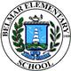
Bernardsville Middle School  [ Map It! | Profile ]  141 Seney Drive  Bernardsville, NJ 07924 | Facility Type: K-12 School  Owner: Somerset Hills School District  Property Manager: Somerset Hills School District  Label Years: 2010
C.J. Davenport Elementary School  [ Map It! | Profile ]  2501 Spruce Avenue  Egg Harbor Township, NJ 08232 | Facility Type: K-12 School  Owner: Egg Harbor Township School District  Property Manager:  Label Years: 2013, 2014
Central High School  [ Map It! | Profile ]  246 18th Avenue  Newark, NJ 07103 | Facility Type: K-12 School  Owner: Newark Public Schools  Property Manager:  Label Years: 2013
Davenport Primary School  [ Map It! | Profile ]  2499 Spruce Avenue  Egg Harbor Township, NJ 08232 | Facility Type: K-12 School  Owner: Egg Harbor Township School District  Property Manager:  Label Years: 2013
Dr. Joyanne D. Miller Elementary School  [ Map It! | Profile ]  2 Alder Avenue  Egg Harbor Township, NJ 08232 | Facility Type: K-12 School  Owner: Egg Harbor Township School District  Property Manager:  Label Years: 2013, 2014
E.W. Slaybaugh Elementary School  [ Map It! | Profile ]  11 Swift Drive  Egg Harbor Township, NJ 08232 | Facility Type: K-12 School  Owner: Egg Harbor Township School District  Property Manager:  Label Years: 2013, 2014
Edison Intermediate School  [ Map It! | Profile ]  800 Rahway Ave.  Westfield, NJ 07090 | Facility Type: K-12 School  Owner: Westfield Board of Education  Property Manager:  Label Years: 2009, 2014
Egg Harbor Township High School  [ Map It! | Profile ]  24 High School Dr.  Egg Harbor Township, NJ 08232 | Facility Type: K-12 School  Owner: Egg Harbor Township School District  Property Manager:  Label Years: 2013, 2014
Eisenhower Intermediate School  [ Map It! | Profile ]  791 Eisenhower Avenue  Bridgewater, NJ 08807 | Facility Type: K-12 School  Owner: Bridgewater-Raritan Regional School District  Property Manager:  Label Years: 2009
Franklin ES  [ Map It! | Profile ]  780 Prospect St.  Westfield, NJ 07090 | Facility Type: K-12 School  Owner: Westfield Board of Education  Property Manager:  Label Years: 2009, 2014
H. Russell Swift Elementary School  [ Map It! | Profile ]  5 Swift Drive  Egg Harbor Township, NJ 08232 | Facility Type: K-12 School  Owner: Egg Harbor Township School District  Property Manager:  Label Years: 2013, 2014
Holmdel High School/W.R. Satz School  [ Map It! | Profile ]  24 Crawfords Corner Road  Holmdel, NJ 07733 | Facility Type: K-12 School  Owner: Holmdel Township Public Schools  Property Manager: Holmdel Township Public Schools  Label Years: 2011
Indian Hill School  [ Map It! | Profile ]  735 Holmdel Road  Holmdel, NJ 07733 | Facility Type: K-12 School  Owner: Holmdel Township Public Schools  Property Manager: Holmdel Township Public Schools  Label Years: 2011
Intermediate South School  [ Map It! | Profile ]  1675 Pinewald Rd.  Beachwood, NJ 08722 | Facility Type: K-12 School  Owner: Toms River Regional Schools  Property Manager:  Label Years: 2015
Kingsway Regional Middle School  [ Map It! | Profile ]  213 Kings Hughway  Woolwich, NJ 08085 | Facility Type: K-12 School  Owner: Kingsway Regional School District  Property Manager: Kingsway Regional School District  Label Years: 2010, 2012
Linwood Middle School  [ Map It! | Profile ]  25 Linwood Place  North Brunswick, NJ 08902 | Facility Type: K-12 School  Owner: North Brunswick Township Board of Education  Property Manager: North Brunswick Township Board of Education  Label Years: 2012
Lower Middle School  [ Map It! | Profile ]  373 Burnt Hill Road  Skillman, NJ 08558 | Facility Type: K-12 School  Owner: Montgomery Township Board of Education  Property Manager: Energy Education, Inc.  Label Years: 2009
Mendham Township Elementary School  [ Map It! | Full Profile ]  18 West Main Street  Brookside, NJ 07926 | Facility Type: K-12 School  Owner: Mendham Township Public Schools  Property Manager:  Label Years: 2010, 2012, 2013, 2014
Mendham Township Middle School  [ Map It! | Full Profile ]  16 Washington Valley Road  Brookside, NJ 07926 | Facility Type: K-12 School  Owner: Mendham Township Public Schools  Property Manager:  Label Years: 2010, 2012, 2013, 2014
Milltown Primary School  [ Map It! | Full Profile ]  611 Milltown Road  Bridgewater, NJ 08807 | Facility Type: K-12 School  Owner: Bridgewater-Raritan Regional School District  Property Manager:  Label Years: 2008, 2009
Notre Dame High School  [ Map It! | Profile ]  601 Lawrence Rd  Lawrenceville, NJ 08648 | Facility Type: K-12 School  Owner: Notre Dame High School  Property Manager:  Label Years: 2011, 2013, 2014
Parsons Elementary School  [ Map It! | Profile ]  899 Hollywood Street  North Brunswick, NJ 08902 | Facility Type: K-12 School  Owner: North Brunswick Township Board of Education  Property Manager: North Brunswick Township Board of Education  Label Years: 2012
Pennington Montessori School  [ Map It! | Profile ]  4 Tree Farm Road  Pennington, NJ 08534 | Facility Type: K-12 School  Owner: Pennington Montessori  Property Manager: Pennington Montessori  Label Years: 2010, 2012
Roosevelt Intermediate School  [ Map It! | Profile ]  301 Clark St.  Westfield, NJ 07090 | Facility Type: K-12 School  Owner: Westfield Board of Education  Property Manager:  Label Years: 2009, 2014
Rumson Fair Have Regional High School  [ Map It! | Profile ]  74 Ridge Road  Rumson, NJ 07760 | Facility Type: K-12 School  Owner: Rumson Fair Haven Regional High School  Property Manager: Rumson-Fair Haven Regional High School  Label Years: 2009
Slaybaugh Primary School  [ Map It! | Profile ]  13 Swift Drive  Egg Harbor Township, NJ 08232 | Facility Type: K-12 School  Owner: Egg Harbor Township School District  Property Manager:  Label Years: 2013
St. Mary of the Lakes School  [ Map It! | Profile ]  196 Route 70  Medford, NJ 08055 | Facility Type: K-12 School  Owner: St. Mary of the Lakes Parish  Property Manager:  Label Years: 2010, 2012
Stony Brook Elementary  [ Map It! | Profile ]  20 Stephenson Road  Pennington, NJ 08534 | Facility Type: K-12 School  Owner: Hopewell Valley Regional School District  Property Manager: Hopewell Valley Regional School District  Label Years: 2012
Tamaques ES  [ Map It! | Profile ]  641 Willow Grove  Westfield, NJ 07090 | Facility Type: K-12 School  Owner: Westfield Board of Education  Property Manager:  Label Years: 2009, 2014
The Pingry School  [ Map It! | Profile ]  131 Martinsville Rd.  Martinsville, NJ 08836 | Facility Type: K-12 School  Owner: The Pingry School  Property Manager: The Pingry School  Label Years: 2012
The Willow School  [ Map It! | Profile ]  1150 Pottersville Road  Gladstone, NJ 07934 | Facility Type: K-12 School  Owner: The Willow School  Property Manager: Energy Solutions  Label Years: 2012
Upper Middle School  [ Map It! | Profile ]  375 Burnt Hill Road  Skillman, NJ 08558 | Facility Type: K-12 School  Owner: Montgomery Township Board of Education  Property Manager: Energy Education, Inc.  Label Years: 2009
Village School  [ Map It! | Profile ]  67 McCampbell Road  Holmdel, NJ 07733 | Facility Type: K-12 School  Owner: Holmdel Township Public Schools  Property Manager: Holmdel Township Public Schools  Label Years: 2011
Westfield High School  [ Map It! | Profile ]  550 Dorian Rd.  Westfield, NJ 07090 | Facility Type: K-12 School  Owner: Westfield Board of Education  Property Manager:  Label Years: 2014
Wilson ES  [ Map It! | Profile ]  325 Linden Ave.  Westfield, NJ 07090 | Facility Type: K-12 School  Owner: Westfield Board of Education  Property Manager:  Label Years: 2014

New Jersey: 8 of 10 EHT School Buildings Earn Energy Star Ratings

Thursday, March 27, 2014
By: Laura Stetser
Shore News Today
EGG HARBOR TOWNSHIP – Eight of out the 10 Egg Harbor Township School District buildings are now certified as Energy Star facilities by the U.S. Environmental Protection Agency.
More commonly thought of as a designation for home appliances, the national certification signifies that these buildings perform in the top 25 percent of similar facilities nationwide for energy efficiency and that they meet strict energy efficiency performance levels set by the EPA.
Through a lengthy application process that scored each building’s energy use on a scale of 100, the schools had to achieve a score of 75 or above in order to qualify.
Slaybaugh Elementary School is ranked the highest in its application with a score of 96, followed by the Dr. Joyanne D. Miller School with 89, Alder Avenue Middle School with 85 and Egg Harbor Township High School with 82. Swift Elementary School also qualified with a score of 81. Davenport Elementary and Primary Schools ranked with scores of 80 and 75 respectively.
Slaybaugh Primary School also made the grade with a score of 77, according to Shawn Braue, the district’s energy education specialist.
Braue said the other two schools are on their way to the certification as well.
“Fernwood Avenue Middle School needs some planned renovations, as does Eagle Academy in order to get qualified to submit them,” he said.
The Energy Star certification is just a part of what the district is implementing since the energy education specialist position was created in 2011.
While partnering with the faculty and staff at the schools has been a cornerstone of the district’s efforts from the outset, Braue has worked to expand the program into learning opportunities for the students as well.
The school’s Key Club has been recruited to design energy posters that are placed throughout the school, and on the district’s webpage, devoted to sharing energy tips as well as the monthly energy savings, is being designed and maintained by students in Lynn Kesselman’s computer science classes.
Sophomore Catelynn Miner is the main point of contact for the site, handling requests from Braue to upload and update documents.
“The students come up with facts and tips that we can share with the community,” Braue said. “I rely on them to give me ideas.”
Kesselman said like the other web pages her students create for the district, the energy website project provides a chance to create a real-world portfolio that they can use as proof of their skills. The students who work on the site have their names listed as creators at the bottom.
“They have to create a storyboard, a color scheme, images, slideshows and a vision for the page,” she said. After that, the young programmers build the page and present it to the class for a peer review before it goes live.
Braue said the partnership with the students is saving him energy as well.
“I can’t tell you the time this saves me,” he said. “We normally update it once a month at least and then as needed in between that.”
Braue said there is plenty of work still to be done to save even more energy and money for the district. Fernwood and Eagle Academy are on his radar for reductions through system upgrades and other measures.
The district’s monthly energy savings reports and the students’ design work can be viewed athttp://www.eht.k12.nj.us/ under the District Services section. Click on “Energy Education.”
http://www.shorenewstoday.com/snt/news/index.php/egg-harbor-twp/eht-general-news/50703-8-of-10-eht-school-buildings-earn-energy-star-ratings.html
< Return to News Listings

